User Manual Specification
Release Version -1.1
For
Meghna Solar Ltd.
Concern Topic: General Configuration

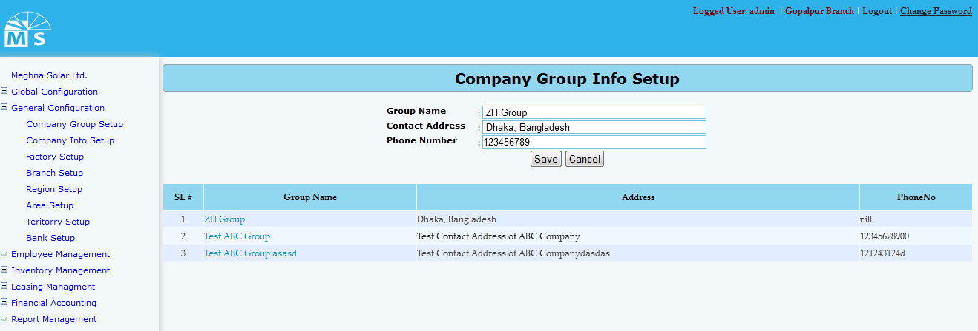

Company Group Info Setup

Here, user needs to enter Group Name, Contact Address and Phone No. of the company in the text box and click Save Button to save Company group information. Recently saved Company group information will be visible in the below grid view. For updating any information user need to click on the Group name in the grid view. Then after modifying the division info in the Upper text box like the picture below, user need to Press Update button. After this, modified Company group information will be seen in the grid view. In this process user can also delete data.
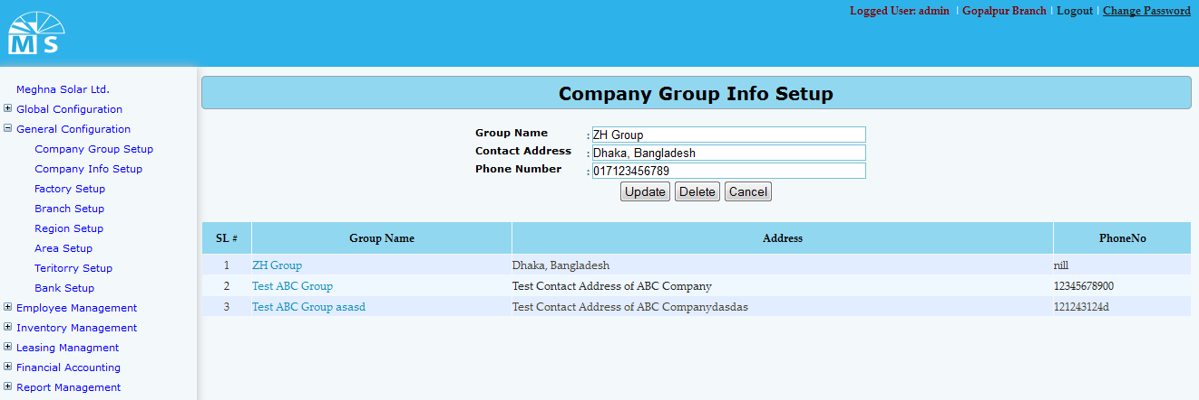

Company Group Info Update
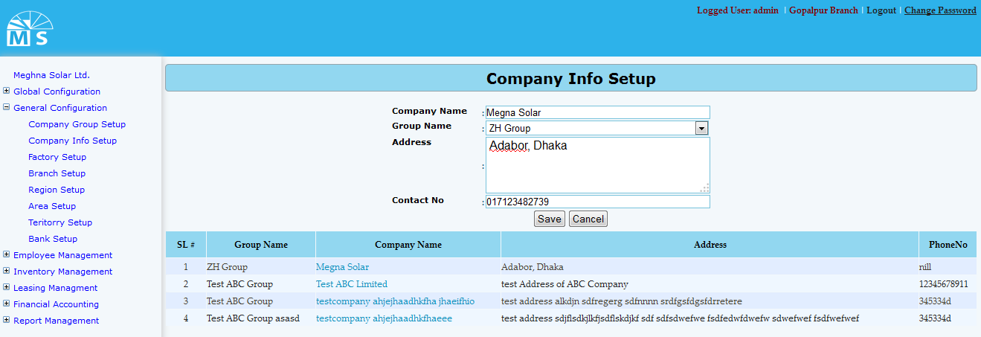

Company Info Setup
Here user needs to enter Company name and select Group name from the dropdown list. Then enter Company address and contact no. in the text box and click Save Button to save Company Information. Recently saved Information will be visible in the below grid view. For updating any Company information user need to click on the Company name in the grid view. Then after modifying the information, user need to Press Update button. After this, modified Company information can be seen in the grid view.
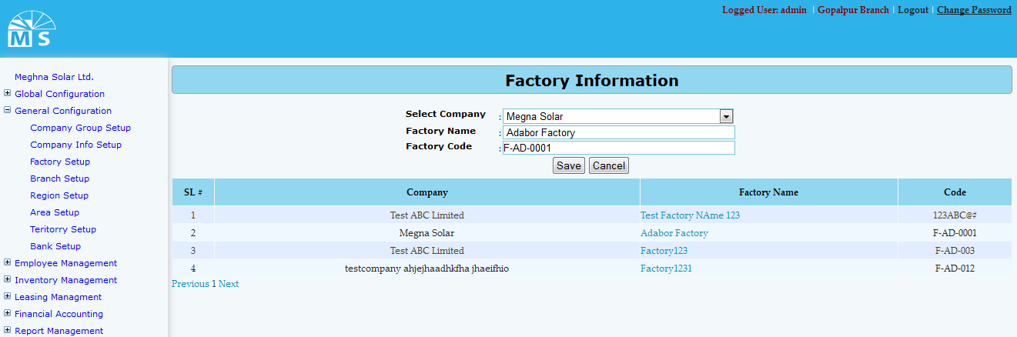

Factory Info Setup

Here user needs to select Company name from the dropdown list. Then enter Factory Name and Factory Code in the text box and click Save Button to save Factory Information. Recently saved Factory Information will be visible in the below grid view. For updating any Factory Information user need to click on the Factory name in the grid view. Then after modifying the Factory Information user need to Press Update button. After that, modified Factory Information can be seen in the grid view.

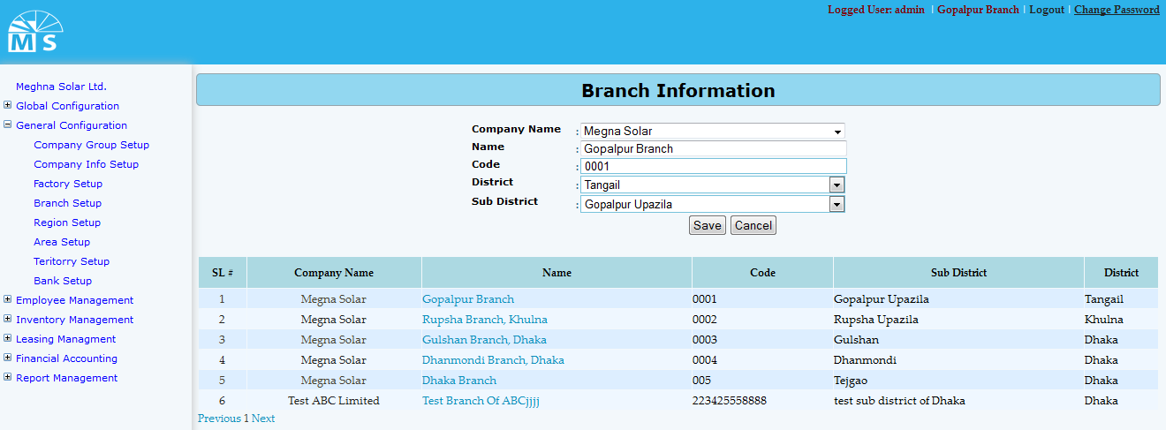

Branch Info Setup
Here user needs to select Company name, District name and Sub District name from the following dropdown list. Then enter Branch name and Code in the text box and click Save Button to save the Branch. Recently saved Branch will be visible in the below grid view. For updating any Branch Information user need to click on the Branch name in the grid view. Then after modifying the Branch information, user need to Press Update button. After that, modified Branch information can be seen in the grid view.
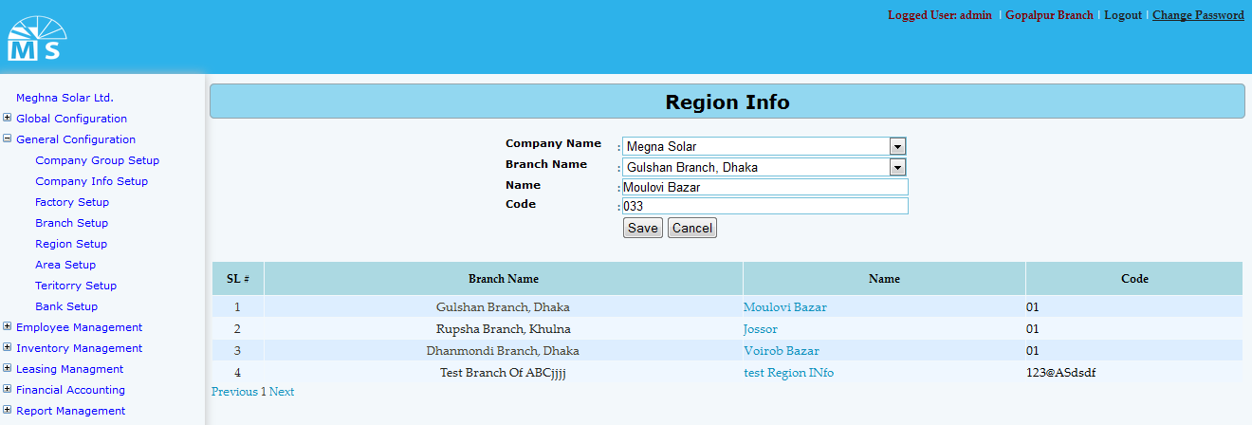

Region Info Setup

Here user needs to select Company name and Branch name from the following dropdown list. Then enter Region name and code in the text box and click Save Button to save the Region. Recently saved Region will be visible in the below grid view. For updating any Region user need to click on the Region name in the grid view. Then after modifying the Region info in the text box, user need to Press Update button. After this, modified Region information can be seen in the grid view.

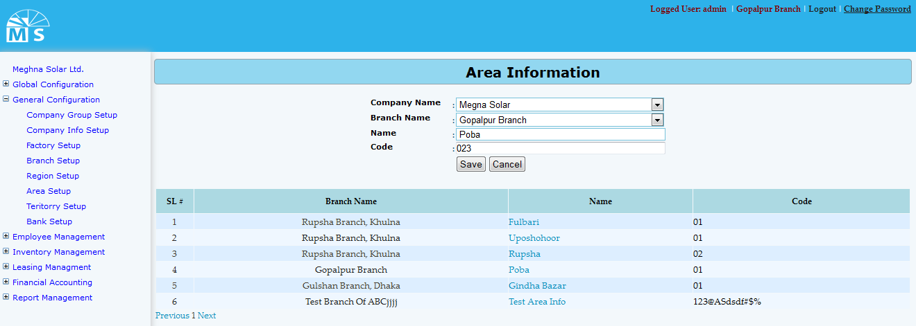

Area info Setup

Here user needs to select Company name and Branch name from the following dropdown list. Then enter Area name and code in the text box and click Save Button to save the Area. Recently saved Area will be visible in the below grid view. For updating any Area user need to click on the Area name in the grid view. Then after modifying the Area info in the text box, user need to Press Update button. After that, modified Area information can be seen in the grid view.
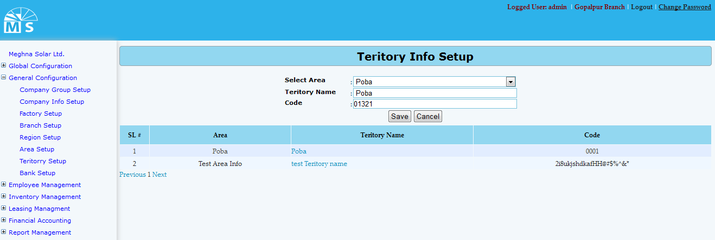

Teritory Info Setup

Here user needs to select Company name and Branch name from the following dropdown list. Then enter Area name and code in the text box and click Save Button to save the Area. Recently saved Area will be visible in the below grid view. For updating any Area user need to click on the Area name in the grid view. Then after modifying the Area info in the text box, user need to Press Update button. After that, modified Area information can be seen in the grid view.
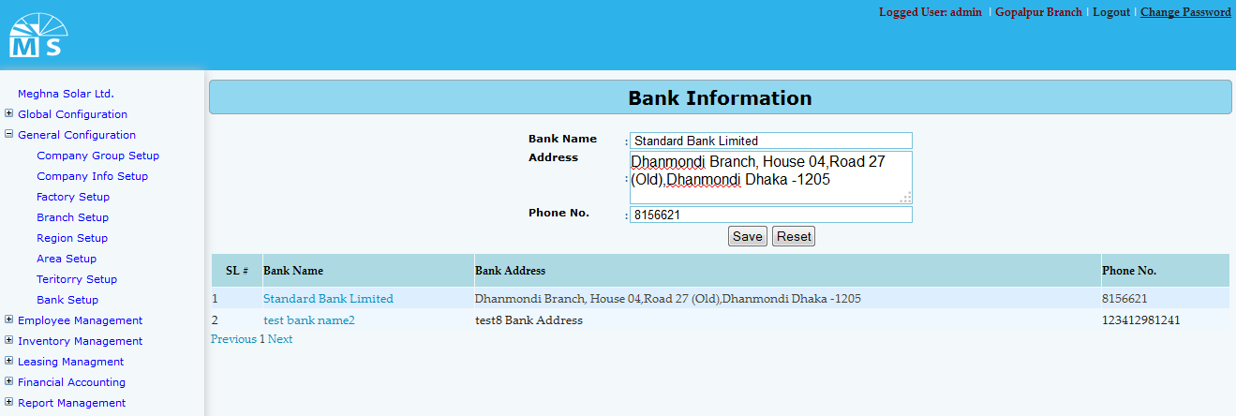

Bank Info Setup

Here user needs to enter Bank name, Bank address and Phone No. in the text box and click Save Button to save the Bank. Recently saved Bank will be visible in the below grid view. For updating any Bank user need to click on the Bank name in the grid view. Then after modifying the Bank info in the text box, user need to Press Update button. After that, modified Bank information can be seen in the grid view

